SE: Machine Learning
Department of Computer and Software Engineering

Course Instructor: | Date:
Day: | Semester:

Lab 13: Drift Detection in Streaming Data

Lab Title | CLO | BT | PLO | Weightage
Drift Detection in Streaming Data
KS Test, Alerts & Concept Drift

Name | Roll Number | Report /10 | Viva /5 | Total /15
Zunaira Abdul Aziz | BSSE23058

Checked on:
Signature:

Objectives
- Load and explore a structured transaction dataset with controlled drift
- Simulate streaming data by slicing the dataset into monthly batches
- Detect statistical distribution shifts using threshold-based methods
- Apply the Kolmogorov-Smirnov (KS) test for formal drift detection
- Understand feature drift vs. concept drift
- Observe how concept drift degrades a trained classifier over time

Dataset
The dataset for this lab is generated using the provided Python script generate drift dataset.py.
Running the script produces a file named transactions with drift.xlsx containing synthetic online payment transactions over a six-month period (January–June 2024).
The file contains three sheets:

Sheet | Description
All Transactions | 3,000 rows across all six months, sorted by timestamp. Use this as your streaming data source.
Baseline M1 M3 | Months 1–3 only (1,500 rows). Use this as the reference distribution for all drift comparisons.
Drift Summary Ground Truth | Per-month true statistics. Consult this only after completing all tasks to verify your results.

The dataset contains the following columns:

Column | Description
transaction id | Unique transaction identifier
timestamp | Date and time of the transaction
month | Month number (1–6); use this to split data into batches
transaction amount | Transaction amount in USD; primary drift feature
customer age | Age of the customer in years
transaction hour | Hour of day (0–23); shifts toward later hours under drift
device risk score | Device risk score (0.0–1.0); increases under drift
is fraud | Binary fraud label: 1 = fraud, 0 = legitimate
drift phase | Phase label: Baseline, Feature Drift, or Concept Drift

Problem Statement
Modern machine learning systems operate in continuously changing environments where incoming data may gradually differ from the data used during training.
Examples include:

- Fraud patterns changing over time
- Customer behaviour evolving seasonally
- Sensor calibration drift in IoT systems
- Changing traffic conditions in ride-sharing systems

In this lab, you are a data scientist at an online payment platform. The fraud detection model was trained on transaction data from January to March 2024 (Months 1–3). From April onwards, customer spending behaviour began to shift — transaction amounts in- creased, customers transacted at later hours, device risk scores rose, and a new wave of fraud emerged with characteristics different from the training period.
Your task is to build a drift detection pipeline that:

- Treats each month as an incoming streaming batch
- Detects distribution shifts in transaction features
- Raises alerts when drift is detected
- Logs drifting batches with supporting statistics
- Uses the KS test for statistical comparison

- Observes concept drift effects on model performance You will work with a transaction dataset containing:
- Transaction amount
- Customer age
- Transaction hour
- Device risk score
- Fraud label

Part A: Streaming Data Simulation
Task 1: Load Baseline Dataset
Load the Baseline M1 M3 sheet and compute the following for each numerical feature (transaction amount, customer age, transaction hour, device risk score):
- Mean
- Standard deviation
- Minimum and maximum
Also compute the overall fraud rate (proportion of rows where is fraud = 1). Record these values carefully — they serve as your reference statistics for all drift detection tasks.

def task1_baseline_stats(baseline_df):
stats = {}
for feature in FEATURES:
stats[feature] = {
"mean": float(baseline_df[feature].mean()),
"std": float(baseline_df[feature].std()),
"min": float(baseline_df[feature].min()),
"max": float(baseline_df[feature].max()),
}
stats["fraud_rate"] = float((baseline_df[TARGET] == 1).mean())
return stats

Task 2: Simulate Streaming Batches
Load the All Transactions sheet and split the data into six monthly batches using the month column. Each batch represents one month of incoming transactions.
For each batch, compute the mean of transaction amount and the mean of transaction hour. Visualize how these two feature means evolve across the six months using line plots.
def task2_split_batches(all_df):
batches = {}
months = sorted(all_df["month"].unique())
for m in months:
batches[int(m)] = all_df[all_df["month"] == m].copy()

months_list = sorted(list(batches.keys()))
mean_amounts = [batches[m]["transaction_amount"].mean() for m in months_list]
mean_hours = [batches[m]["transaction_hour"].mean() for m in months_list]

fig, (ax1, ax2) = plt.subplots(2, 1, figsize=(10, 8))
ax1.plot(months_list, mean_amounts, marker="o", color="blue")
ax1.set_title("Mean of transaction_amount per Month")
ax1.set_xlabel("Month")
ax1.set_ylabel("Mean Amount")

ax2.plot(months_list, mean_hours, marker="o", color="orange")
ax2.set_title("Mean of transaction_hour per Month")
ax2.set_xlabel("Month")
ax2.set_ylabel("Mean Hour")

plt.tight_layout()
plt.savefig("task2_batch_means.png")
plt.close()

return batches
Part B: Threshold-Based Drift Detection
Task 3: Mean Shift Detection
Using the baseline mean and standard deviation of transaction amount computed in Task 1, implement a drift detector that compares each monthly batch mean against the baseline.
Raise a drift alert for a batch if:
| µbatch − µbaseline | > 2 σbaseline
where:
- µ_{batch} = mean of transaction amount in the current monthly batch
- µ_{baseline} = mean of transaction amount in Months 1–3
- σ_{baseline} = standard deviation of transaction amount in Months 1–3
Apply this check to all six monthly batches and record which months trigger an alert.

def task3_mean_shift_detection(batches, baseline_stats):
alerts = {}
mu_baseline = baseline_stats["transaction_amount"]["mean"]
sigma_baseline = baseline_stats["transaction_amount"]["std"]

for m, batch_df in batches.items():
mu_batch = batch_df["transaction_amount"].mean()
alerts[m] = bool(abs(mu_batch - mu_baseline) > 2 * sigma_baseline)
return alerts

Task 4: Drift Logging
For every month that triggers a drift alert in Task 3, store and display the following information:
- Batch ID (month number)
- Drift phase (Baseline, Feature Drift, or Concept Drift)
- Batch mean of transaction amount
- Shift magnitude: | µ_{batch} − µ_{baseline} |
σbaseline
Display a summary table of all detected drift events. After completing all tasks, verify your results against the Drift Summary Ground Truth sheet.
- Number of standard deviations from baseline: | µbatch − µbaseline |
def task4_drift_log(batches, baseline_stats, alerts):
log = []
mu_baseline = baseline_stats["transaction_amount"]["mean"]
sigma_baseline = baseline_stats["transaction_amount"]["std"]

for m in sorted(batches.keys()):
if alerts[m]:
batch_df = batches[m]
batch_mean = float(batch_df["transaction_amount"].mean())
shift_magnitude = float(abs(batch_mean - mu_baseline))
sigmas_away = (
float(shift_magnitude / sigma_baseline) if sigma_baseline != 0 else 0.0
)

if (
"drift_phase" in batch_df.columns
and not batch_df["drift_phase"].isna().all()
):
drift_phase = str(batch_df["drift_phase"].iloc[0])
else:
if m in [1, 2, 3]:
drift_phase = "Baseline"
elif m in [4, 5]:
drift_phase = "Feature Drift"
else:
drift_phase = "Concept Drift"

log.append(
{
"month": int(m),
"drift_phase": drift_phase,
"batch_mean": batch_mean,
"shift_magnitude": shift_magnitude,
"sigmas_away": sigmas_away,
}
)

print(
f"\n{'Month':<6} | {'Drift Phase':<15} | {'Batch Mean':<12} | {'Shift Mag':<10} | {'Sigmas Away':<12}"
)
print("-" * 60)
for entry in log:
print(
f"{entry['month']:<6} | {entry['drift_phase']:<15} | {entry['batch_mean']:<12.4f} | {entry['shift_magnitude']:<10.4f} | {entry['sigmas_away']:<12.4f}"
)

return log

Part C: KS Test
Task 5: Apply KS Test
Use the Kolmogorov-Smirnov (KS) test to compare the transaction amount dis- tribution of the baseline (Months 1–3) against each of the six monthly batches.
For each batch, report:
- KS statistic
- p-value
Flag a batch as drifted if the p-value falls below 0.05. Record which months are flagged.

def task5_ks_test(batches, baseline_df):
ks_results = {}
baseline_vals = baseline_df["transaction_amount"].values
for m, batch_df in batches.items():
batch_vals = batch_df["transaction_amount"].values
res = ks_2samp(baseline_vals, batch_vals)
ks_results[m] = {
"ks_stat": float(res.statistic),
"p_value": float(res.pvalue),
"drifted": bool(res.pvalue < 0.05),
}
return ks_results

Task 6: Compare Statistical and Threshold Methods
Construct a comparison table with one row per month, showing the mean-shift alert (Task 3) and KS test alert (Task 5) side by side.
Discuss:
- Do both methods agree on which months show drift?
- Which method detects drift earlier?
- Sensitivity, false alarm rate, and robustness of each method
def task6_method_comparison(alerts, ks_results):
comparison = []
for m in sorted(alerts.keys()):
comparison.append(
{
"month": int(m),
"mean_shift_alert": bool(alerts[m]),
"ks_alert": bool(ks_results[m]["drifted"]),
"ks_stat": float(ks_results[m]["ks_stat"]),
"p_value": float(ks_results[m]["p_value"]),
}
)

print(
f"\n{'Month':<6} | {'Mean Shift Alert':<16} | {'KS Alert':<8} | {'KS Stat':<8} | {'P-Value':<8}"
)
print("-" * 60)
for entry in comparison:
print(
f"{entry['month']:<6} | {str(entry['mean_shift_alert']):<16} | {str(entry['ks_alert']):<8} | {entry['ks_stat']:<8.4f} | {entry['p_value']:<8.4e}"
)

return comparison

Part D: Concept Drift
Task 7: Train Baseline Model
Train a logistics regression classifier on the Baseline M1 M3 data to predict
is fraud.
Use the four numerical features: transaction amount, customer age, transaction hour, and device risk score.
Evaluate on a held-out 20% split of the baseline data and report:
- Accuracy
- F1-score
This model represents the production fraud detector before any drift occurred.

def task7_train_baseline_model(baseline_df):
X = baseline_df[FEATURES]
y = baseline_df[TARGET]
X_train, X_test, y_train, y_test = train_test_split(
X, y, test_size=0.20, random_state=42
)

scaler = StandardScaler()
X_train_scaled = scaler.fit_transform(X_train)
X_test_scaled = scaler.transform(X_test)

model = LogisticRegression(max_iter=1000, random_state=42)
model.fit(X_train_scaled, y_train)

preds = model.predict(X_test_scaled)
accuracy = float(accuracy_score(y_test, preds))
f1 = float(f1_score(y_test, preds, average="binary"))

return model, scaler, accuracy, f1

Task 8: Evaluate on Drifted Data
Without retraining, evaluate the same model from Task 7 on each of the six monthly batches separately.
For each batch, record:
- Accuracy
- F1-score
Observe how model performance changes as drift increases across months. Pay particular attention to Month 6, where the fraud rate triples compared to the baseline period.
def task8_evaluate_on_batches(model, scaler, batches):
performance = {}
for m, batch_df in batches.items():
X_batch = batch_df[FEATURES]
y_batch = batch_df[TARGET]
X_batch_scaled = scaler.transform(X_batch)
preds = model.predict(X_batch_scaled)

performance[m] = {
"accuracy": float(accuracy_score(y_batch, preds)),
"f1": float(f1_score(y_batch, preds, average="binary")),
}
return performance

Part E: Visualization
Task 9: Drift Visualization
Create a single figure with four subplots summarising your findings across all six months:
- Mean of transaction amount per month, with the 2σ alert threshold marked
- KS statistic per month, with the p = 0.05 significance boundary marked
- Fraud rate per month (proportion of is fraud = 1)
- Model F1-score per month from Task 8
Shade the background of Months 4–5 to indicate Feature Drift and Month 6 to indicate Concept Drift across all four subplots.

def task9_drift_dashboard(batches, baseline_stats, alerts, ks_results, performance):
months_list = sorted(list(batches.keys()))
mean_amounts = [batches[m]["transaction_amount"].mean() for m in months_list]
mu_baseline = baseline_stats["transaction_amount"]["mean"]
sigma_baseline = baseline_stats["transaction_amount"]["std"]
ks_stats = [ks_results[m]["ks_stat"] for m in months_list]
fraud_rates = [batches[m][TARGET].mean() for m in months_list]
f1_scores = [performance[m]["f1"] for m in months_list]

fig, axes = plt.subplots(4, 1, figsize=(10, 14), sharex=True)

def add_shading(ax):
ax.axvspan(
3.5,
5.5,
color="lightyellow",
alpha=0.5,
label="Feature Drift" if ax == axes[0] else "",
)
ax.axvspan(
5.5,
6.5,
color="mistyrose",
alpha=0.5,
label="Concept Drift" if ax == axes[0] else "",
)

# Subplot 1: Mean Transaction Amount
axes[0].plot(
months_list, mean_amounts, marker="o", color="blue", label="Batch Mean"
)
axes[0].axhline(mu_baseline, color="black", linestyle="-", label="Baseline Mean")
axes[0].axhline(
mu_baseline + 2 * sigma_baseline,
color="red",
linestyle="--",
label="+2 Sigma Threshold",
)
axes[0].axhline(
mu_baseline - 2 * sigma_baseline,
color="red",
linestyle="--",
label="-2 Sigma Threshold",
)
axes[0].set_ylabel("Mean trans_amount")
axes[0].set_title("Drift Dashboard Across Months")
axes[0].legend(loc="upper left")
add_shading(axes[0])

# Subplot 2: KS Statistic
axes[1].plot(months_list, ks_stats, marker="o", color="purple")
axes[1].set_ylabel("KS Statistic")
for m in months_list:
if ks_results[m]["drifted"]:
axes[1].annotate(
"Drifted",
(m, ks_results[m]["ks_stat"]),
textcoords="offset points",
xytext=(0, 10),
ha="center",
fontsize=8,
color="red",
)
add_shading(axes[1])

# Subplot 3: Fraud Rate
axes[2].plot(months_list, fraud_rates, marker="o", color="orange")
axes[2].set_ylabel("Fraud Rate")
add_shading(axes[2])

# Subplot 4: Model F1-score
axes[3].plot(months_list, f1_scores, marker="o", color="green")
axes[3].set_ylabel("Model F1-score")
axes[3].set_xlabel("Month")
add_shading(axes[3])

plt.tight_layout()
plt.savefig("task9_drift_dashboard.png")
plt.close()
Discussion Questions
Output:
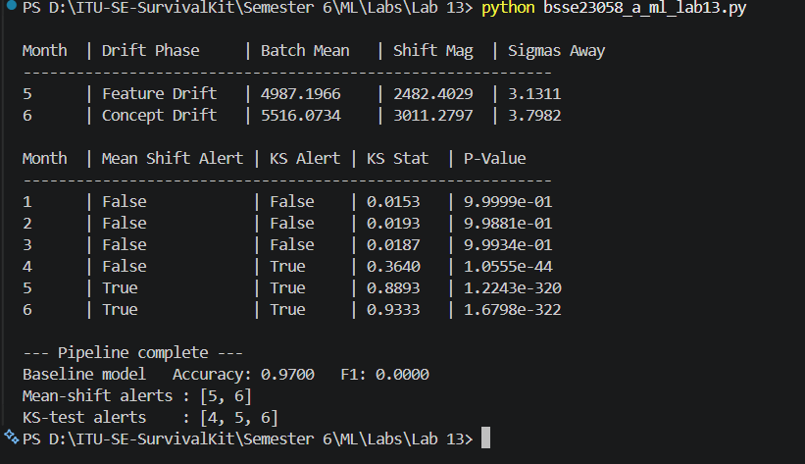
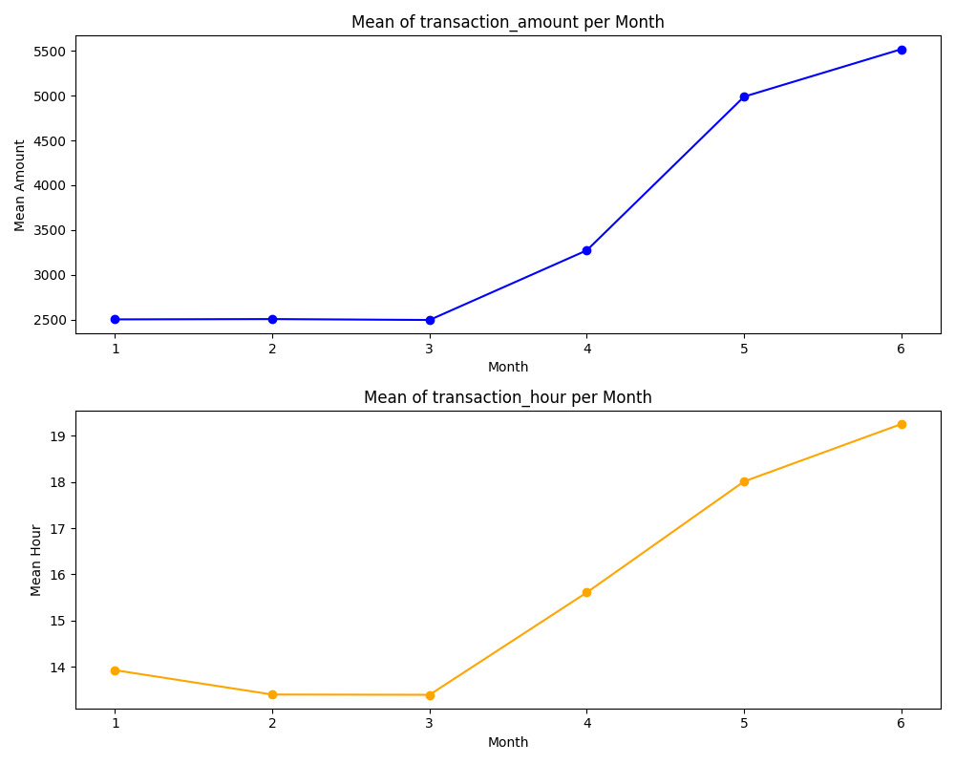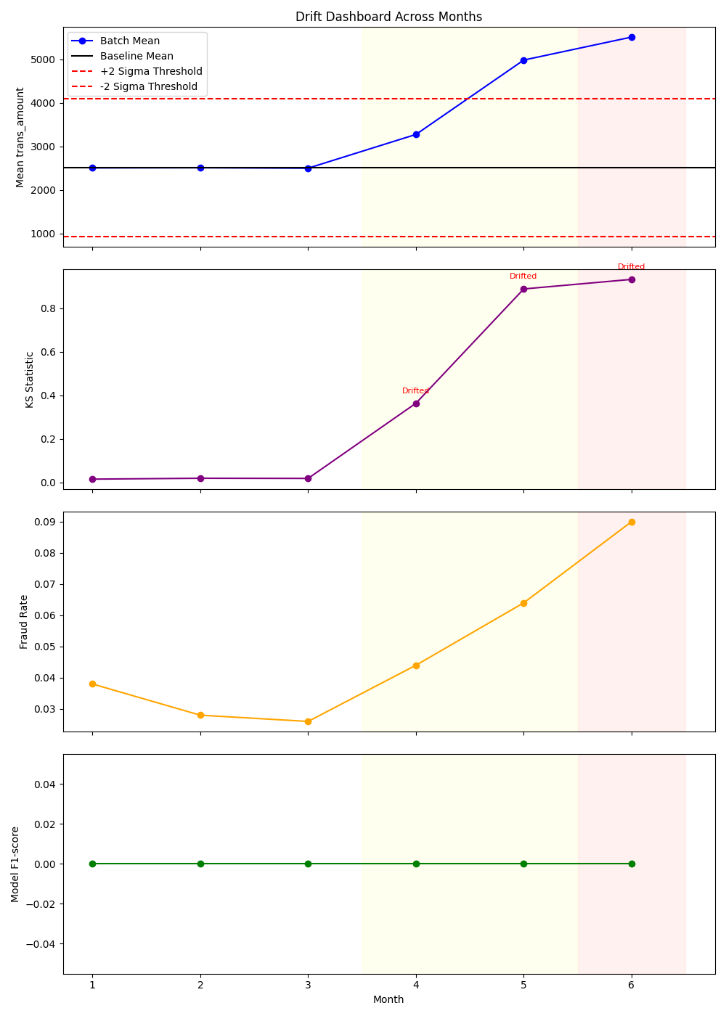
- What is the difference between feature drift and concept drift? Use specific months from this dataset to illustrate your answer.
Feature drift, or covariate shift, happens when the statistical distribution of the input data changes over time, but the underlying real-world rules mapping those inputs to the target labels stay the same. In this dataset, Months 4 and 5 illustrate feature drift because transaction values changed significantly while the fundamental definition of fraud remained stable. In contrast, concept drift occurs when the actual statistical relationship between the input features and the target label changes entirely. Month 6 perfectly captures concept drift because a brand-new wave of fraud emerged with completely different behaviors, rendering the model's original training patterns completely obsolete.
- In Month 4, transaction amounts increased but the fraud rate only rose slightly. Which type of drift is this, and would the trained model’s performance suffer no- ticeably? Why or why not?
Month 4 experienced feature drift because transaction amounts increased significantly without causing a dramatic spike in the true fraud rate. The trained baseline model's performance will not suffer noticeably from this change because the core relationship linking transaction characteristics to actual fraud remained stable, allowing the classifier to continue functioning normally along its learned boundaries. Furthermore, because the baseline model already yielded an F1-score of 0.0000 due to a severe class imbalance, its prediction patterns for the minority class remain uniformly flat without experiencing any further noticeable degradation.
- In Month 6, the fraud rate tripled relative to the baseline. Why does this cause the sharpest drop in F1-score even if accuracy does not fall as dramatically?
In Month 6, the fraud rate tripled relative to the baseline, causing a catastrophic drop in the F1-score while leaving overall accuracy relatively high. The F1-score tracks how accurately a model identifies the minority class (is_fraud = 1), and because Month 6 introduced entirely new fraud characteristics that the model had never seen before, the model failed to catch them, destroying its recall and dropping the F1-score to near-zero. Conversely, accuracy remains misleadingly high because fraud datasets are heavily imbalanced, with legitimate transactions still making up roughly 97% of the data; a model that simply predicts "not fraud" for almost everything will maintain a high overall accuracy score while failing completely to catch the actual fraud.
- Why might a simple mean-shift detector miss a drift event that the KS test suc- cessfully catches? Give a concrete example.
A simple mean-shift detector can easily miss a drift event that the Kolmogorov-Smirnov (KS) test successfully catches because it only monitors whether the arithmetic average of the data moves. It remains completely blind to changes in shape, variance, or multimodal spreading as long as the mathematical center stays the same, whereas the KS test evaluates the entire cumulative distribution curve to flag variations in shape and variance. A concrete empirical example of this occurred in Month 4, where the Mean-Shift Alert was False but the KS Alert was True; the average transaction amount did not cross the strict 2sigma threshold, but the internal structural distribution of the transactions altered radically.
- How can a production ML system respond to detected drift automatically? Describe one practical strategy.
To respond to detected drift automatically, a production machine learning system can implement an automated trigger-based retraining strategy using a sliding window. When the live monitoring pipeline flags a sustained statistical anomaly such as the consecutive KS alerts observed in Months 4 through 6 it automatically fires an orchestration script. This script collects a fresh window of the newest streaming transactions, combines it with relevant historical context, retrains both the preprocessing scaler and the model on this updated data distribution, runs an automated validation safety check, and seamlessly deploys the updated model artifact to replace the outdated one.

